РГПУ им. А.И. Герцена

Тема «Методы решения сетевых задач»

Иванов Д.В., 2ИВТ, 1 группа, 2 подгруппа

***Задача 1***

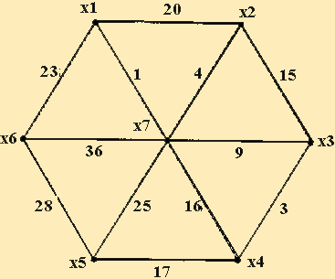  
Найдите минимальный остов дерева.

***Решение***

|  |  |  |  |  |  |  |  |
| --- | --- | --- | --- | --- | --- | --- | --- |
|  | X1 | X2 | X3 | X4 | X5 | X6 | X7 |
| X1 |  |  |  |  |  |  |  |
| X2 | 20 |  |  |  |  |  |  |
| X3 |  | 15 |  |  |  |  |  |
| X4 |  |  | 3 |  |  |  |  |
| X5 |  |  |  | 17 |  |  |  |
| X6 | 23 |  |  |  | 28 |  |  |
| X7 | 1 | 4 | 9 | 16 | 25 | 36 |  |

В сеть не включаем:  
x1->x2=20, так как x1->x7->x2 = 5;  
x2->x3=15, так как x2->x7->x3 = 13;  
x4->x7=16, так как x4->x3->x7 = 12;  
x6->x7=36, так как x6->x1->x7 = 24.

|  |  |  |  |  |  |  |  |
| --- | --- | --- | --- | --- | --- | --- | --- |
|  | X1 | X2 | X3 | X4 | X5 | X6 | X7 |
| X1 |  |  |  |  |  |  |  |
| X2 |  |  |  |  |  |  |  |
| X3 |  |  |  |  |  |  |  |
| X4 |  |  | 3 |  |  |  |  |
| X5 |  |  |  | 17 |  |  |  |
| X6 | 23 |  |  |  | 28 |  |  |
| X7 | 1 | 4 | 9 |  | 25 |  |  |

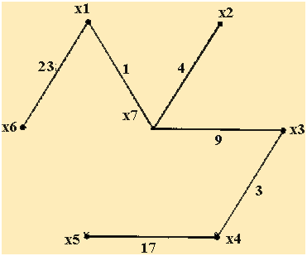

Ответ: вес минимального остовного дерева равен 23+1+4+9+3+17=57

***Задача 2***

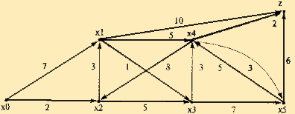  
Найдите кратчайший путь на представленном графе

***Решение***

|  |  |  |  |  |  |  |  |
| --- | --- | --- | --- | --- | --- | --- | --- |
|  | X0 | X1 | X2 | X3 | X4 | X5 | Z |
| X0 |  | 7 | 2 |  |  |  |  |
| X1 |  |  |  | 1 | 5 |  | 10 |
| X2 |  | 3 |  | 5 |  |  |  |
| X3 |  |  |  |  | 3 | 7 |  |
| X4 |  |  | 8 |  |  | 3 | 2 |
| X5 |  |  |  |  | 5 |  | 6 |
| Z |  |  |  |  |  |  |  |

|  |  |  |  |  |  |  |  |
| --- | --- | --- | --- | --- | --- | --- | --- |
|  | X0 | X1 | X2 | X3 | X4 | X5 | Z |
| X0 |  | 7 | 2 |  |  |  |  |
| X1 |  |  |  | 1 | 5 |  | 10 |
| X2 |  | 3 |  | 5 |  |  |  |
| X3 |  |  |  |  | 3 | 7 |  |
| X4 |  |  | 8 |  |  | 3 | 2 |
| X5 |  |  |  |  | 5 |  | 6 |
| Z |  |  |  |  |  |  |  |

Ответ: кратчайший путь x0->x2->x1->x3->x4->z. Вес минимального остовного дерева равен 2 + 3+ 1 + 3 + 2 = 11.  
